30.32: 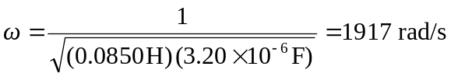
a) 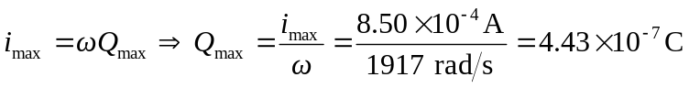
b) From Eq. 31.26 